Meta: In this in-depth Outreach.io review, we've gathered insights on pricing and potential alternatives. Read on to discover our findings and make an informed decision for your sales engagement needs.

Grammarly:

# **In-Depth Outreach.io review: We feel it’s overpriced and too bloated. Here’s why [2025 Updated]**

Are you still doing **manual sales outreach** for your B2B?  
  
If so, you’re wasting both time and money.

It’s time for your sales team to take advantage of the latest engagement tools out there.



Automation has become table stakes in B2B sales in 2025. Anyone who really wants to get ahead is already automating their outreach.

[Outreach.io](http://outreach.io) is a **sales engagement platform** that **automates outreach processes** on cold emails, calls, LinkedIn and more for B2B sales teams.

Outreach.io created this market back in 2014.

Since then, a number of competitors have come out, with **many offering better pricing + capabilities.**

This [Outreach.io](https://outreach.io/) review will help you understand its features, pricing, and alternatives to make an informed decision about whether Outreach is the right platform for your needs.

Before we begin reviewing it, here’s a quick video I recorded about the tool.

[Outreach.io costs over $20k/year Should you invest in such an expensive tool?](https://www.youtube.com/watch?v=Vu0RPqmAbB0)

## **What Is Outreach.io?**

Outreach.io helps B2B sales and marketing teams **automate their outreach process** on cold emails, calls and LinkedIn.

It makes connecting with potential customers easier, ultimately leading to more closed deals.

Since 2014, the software claims to have successfully helped Zoom, Sap, Siemens, Snowflake, and 5,000 other companies increase their sales productivity.

## **What features does Outreach.io offer?**

Outreach.io provides users with a variety of features, these are the core ones:

* **Outreach Engage.**
* **Outreach Guide.**
* **Outreach Commit.**
* **CRM Integration.**

We’ll take a good look at each.

### **Outreach Engage:**

Engage provides a sales engagement solution for sales and business development sales reps.

With **simplified, automated prospecting workflows**, salespeople can build more pipelines and close more deals!

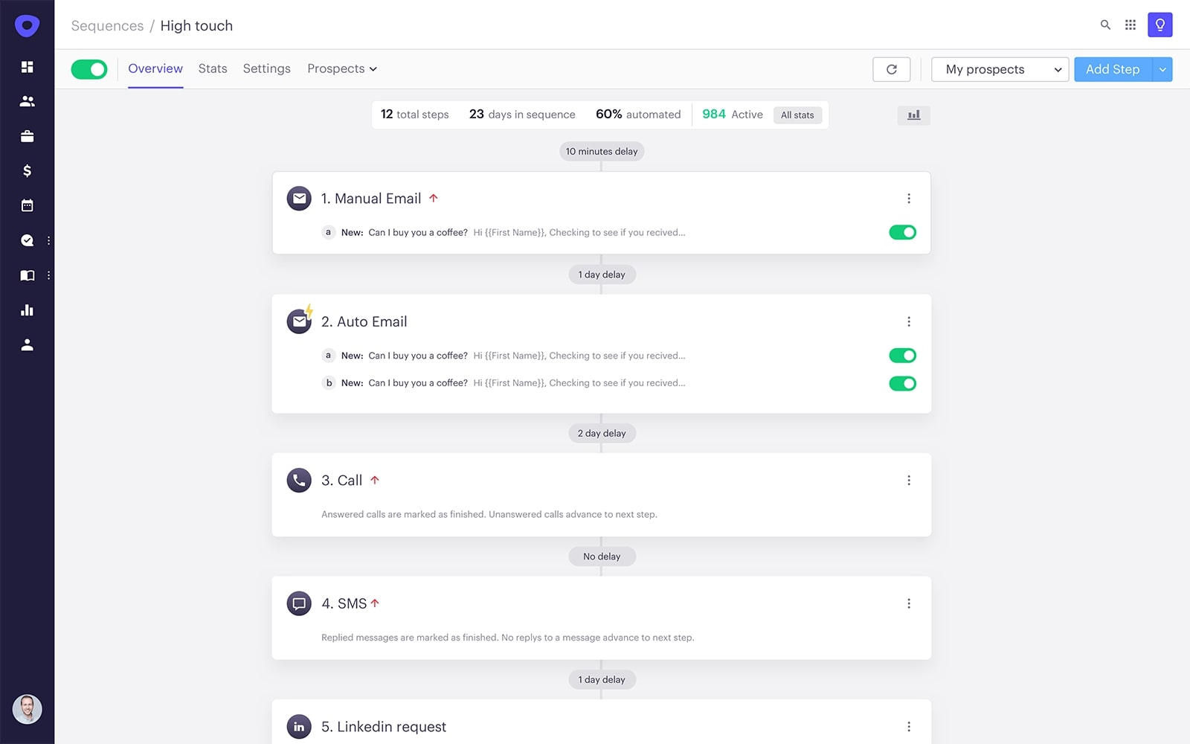

***Source: Outreach.io***

### **Outreach Guide:**

**This AI-powered feature** helps sales reps and managers make decisions and track every moment of the sales cycle.  
  
It helps them record their sales calls and keep track of what was said by both potential buyers and sales reps to help them optimize their performance, almost like athletes do after a soccer match.

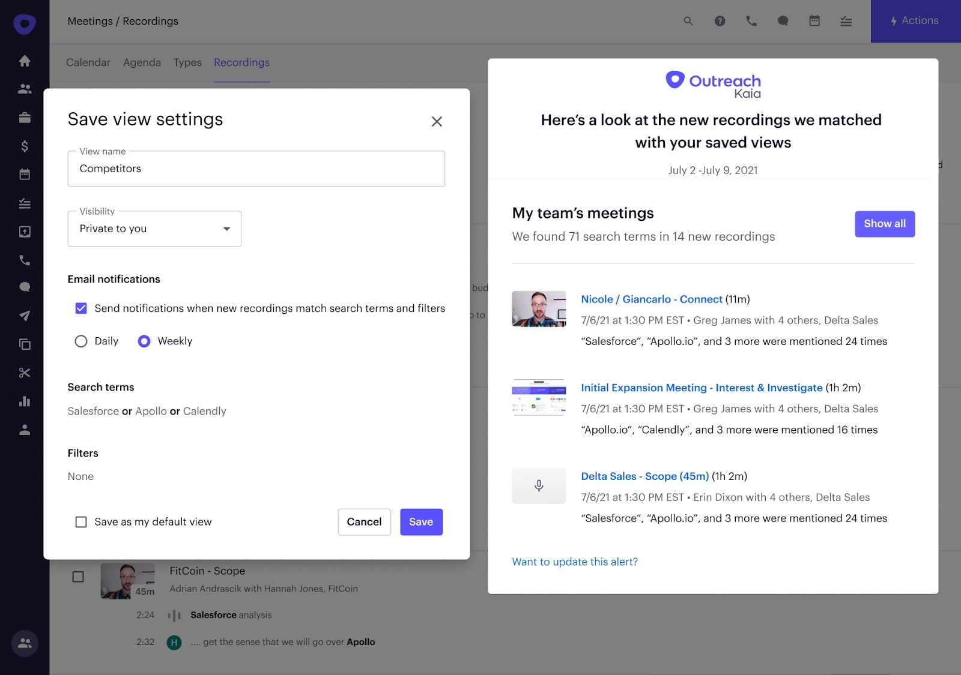

***Source: Outreach.io***

### **Outreach Commit:**

With Outreach Commit, you can create sales forecasts and manage expectations with your executive team.

It also alerts you in advance if it sees signals that you won’t hit your sales quota.

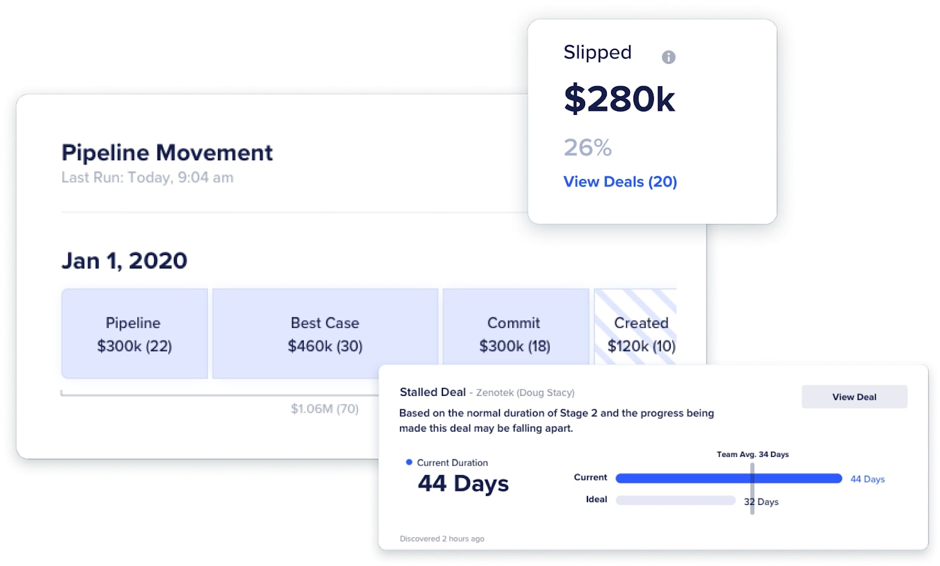

***Source: Outreach.io***

### **CRM Integration:**

Outreach.io claims to support more than 90 integrations, allowing you to have every sales process and tool in one place.

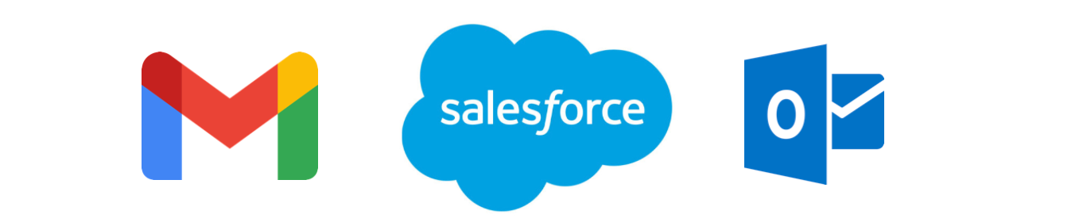

## **How can Outreach.io be used?**

There are plenty of ways you can use Outreach.io, some of which include:

* **AI-controlled Prospecting**: The software automates prospecting on cold email, LinkedIn and more, giving you more time to focus on your business.
* **Detailed analytics:** It provides you with valuable insights into your outreach (for example, are cold emails more effective for your sales team or cold calls. Or what time of the day do most of your cold calls get picked.)   
    
  These insights help you improve your sales process.
* **Sales forecasting:** Its forecasting feature allows you to be in control of your sales pipeline and make necessary changes before you miss your number. .

## **Customer Reviews: What do real users say about Outreach.io?**

Anyone can talk about all their features and capabilities, but what about the real world?

People actually have very **mixed reviews** about Outreach.

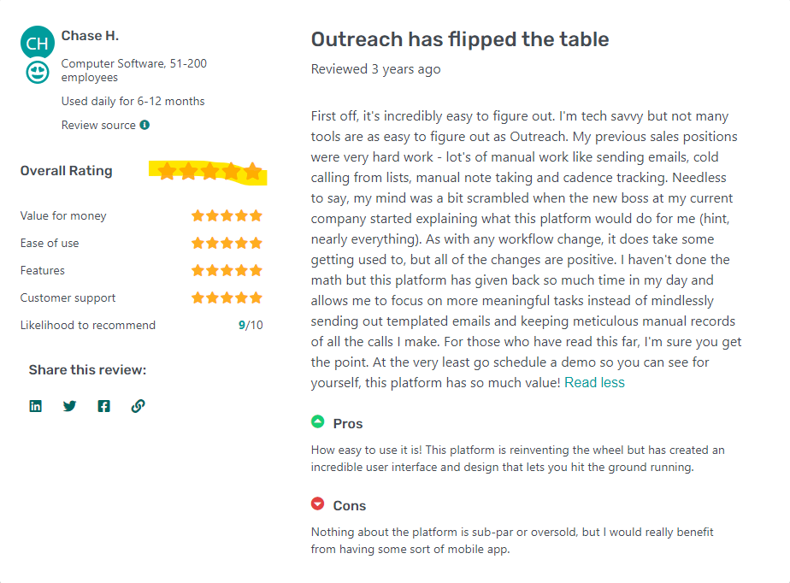

***Source: GetApp***

As we can see here, the customer seems very happy with the product, particularly with its ease of use!

But not everyone thinks so…

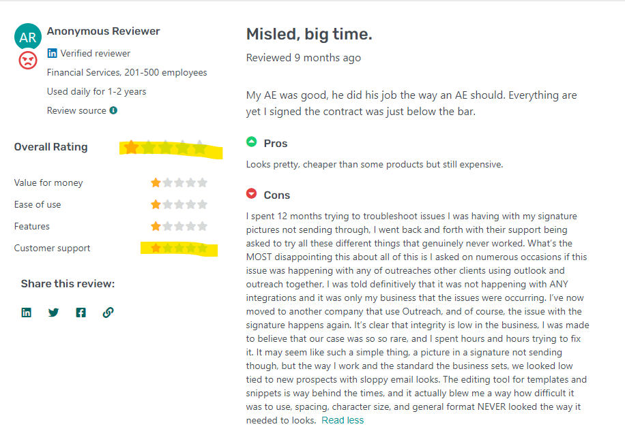

***Source: GetApp***

This customer **faced issues with integrations** and, unfortunately, **could not get help from Outreach.io's customer service.**

A couple of more reviews show the same problem with customer service.

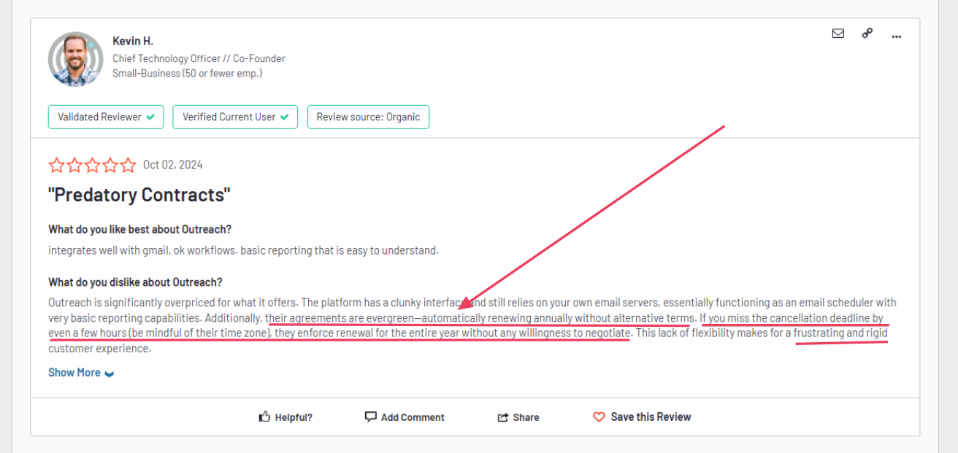

**Source: G2**

Kevin H. had an even worse experience with their **predatory billing practices,** saying they automatically renew for the whole year if you miss the deadline by a couple hours.

Unfortunately, Outreach.io did not show any willingness to negotiate or help him, which raises eyebrows.

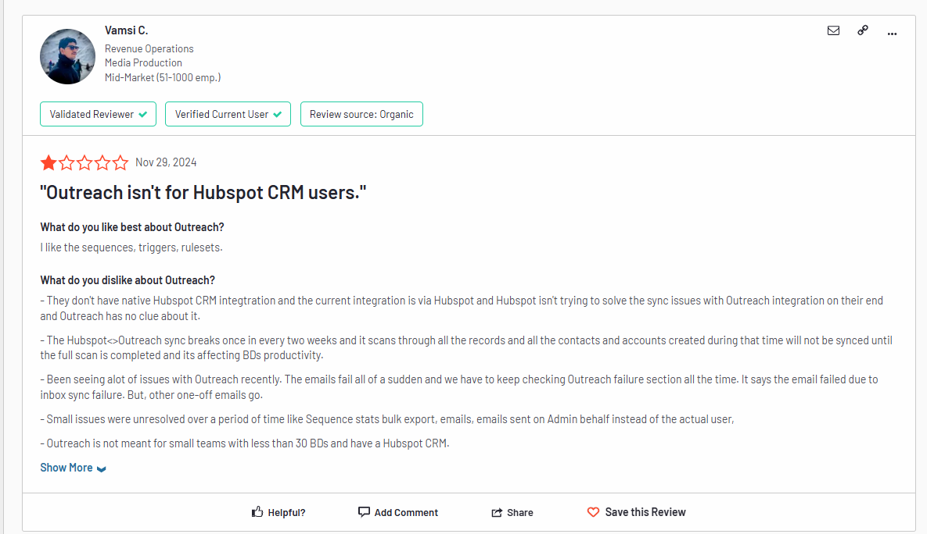

Source: G2

Another review highlights the lack of Hubspot integration, as well as a lot of issues with Outreach itself as **emails keep showing “sync failure”**

In the end, the tool is pretty clunky to use and customer support does not seem very helpful.

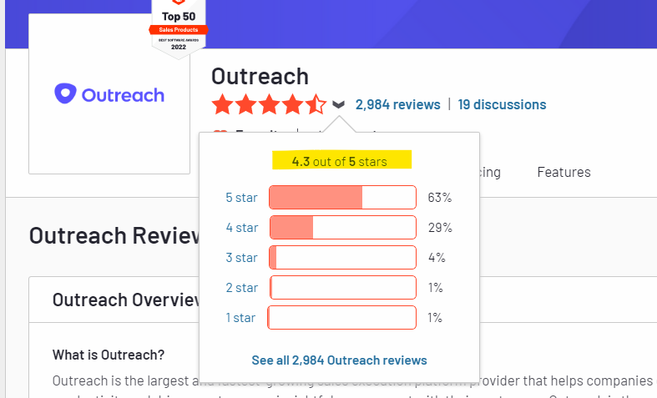

***Source: G2***

Outreach.io receives an **above-average** [**rating of 4.3** on G2](https://www.g2.com/products/outreach/reviews#reviews), which is quite good!

## **Outreach.io Pricing: How much does it cost?**

Even though some of the top B2B sales teams use Outreach.io, it still needs improvement.

The reviews clearly show that technical and customer service glitches have a lot more room to grow.

When it comes to product pricing, Outreach.io's official website **does not display pricing.** You will have to contact their reps to get pricing details for the product.

In today's world, customers look for transparency in pricing, and if it is not available, the company does lose a point!

### **Is Outreach.io worth the price?**

Now that we know its features and pricing, it's time to answer the big question: **Is Outreach.io worth the price?**

The simple answer is: **It depends on your needs!**

It’s an excellent sales engagement platform with additional features like **call recording and sales forecasting.**

**The lack of pricing transparency** can be a big turn-off for customers looking for software according to their budget.

The **predatory billing practices** are also a bit sketchy, topped off with **subpar customer support.**I’ve heard from a few customers that the **pricing starts at $20k a year.**

So, it’s worth the price if you’re a serious B2B sales team looking for a serious all-in-one sales engagement + call recording + sales forecasting platform.

However, if you are new to sales engagement and want to try out other software that is more affordable and easier to understand, you may try the alternatives we have listed in the following section of the blog.

## **What are the top Outreach.io alternatives?**

Finding the right software for your business can be challenging. There are too many options, and they all look the same to the untrained eye.

The criteria we have taken to bring you the best alternatives are:

* **Pricing**: We have considered only those alternatives that are cheaper than Outreach.io or provide a better price-to-feature ratio.
* **Features**: The software features should be at par with it or excel in some areas to be considered an Outreach.io alternative.
* **User Ratings**: We have given preference to those alternatives with better user ratings than Outreach.io.

For your convenience, we have compared and brought you the best two alternatives so that you are no longer confused by more options.

Here are the best Outreach.io alternatives:

* SalesRobot.
* Reply.io

### SalesRobot: The Ultimate #1 Choice for LinkedIn + Email Outreach if you’re a business with less than 20 SDRs and don’t use Salesforce

[SalesRobot](https://www.salesrobot.co/) is a **powerful sales engagement platform designed to streamline your cold outreach efforts across LinkedIn and Email.** 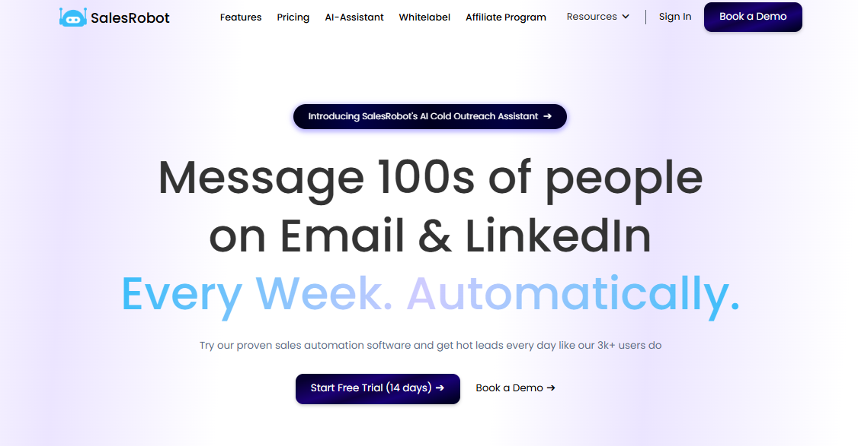

With SalesRobot, you can confidently send [**highly personalized messages**](https://www.salesrobot.co/blogs/hyper-personalized-linkedin-outreach) and track each response, all from **a single, efficient user interface.**

**SalesRobot is trusted by over 3,200 customers**, from lead-generation agencies and start-ups to sales and marketing executives, recruiting firms, and small—to mid-sized businesses.

They appreciate **advanced LinkedIn automation features that make lead generation highly effective** and shorten this process greatly.

**SalesRobot is not just another LinkedIn outreach tool!**

Here is why.

⭐**Outstanding Customer Support:**

Prospecting never sleeps, and campaign issues can come up anytime—yes, even on weekends.

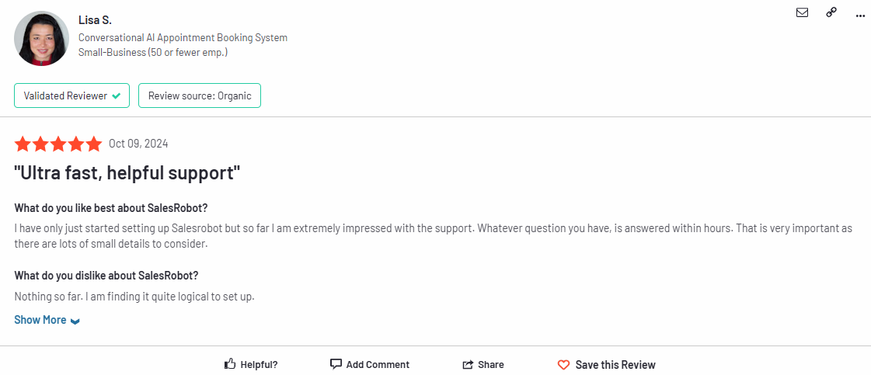

Source: G2

**SalesRobot has 24/7 customer support** to address anything that may be stopping your lead generation in its tracks.

Plus, our support staff is not just highly efficient but also incredibly friendly (you have got to trust me on this one!).

⭐**Bulk Hyper-Personalization:**

Doing all this personalization in bulk manually can be overwhelming.

Just as daunting is the process of remembering every little thing about your prospects!

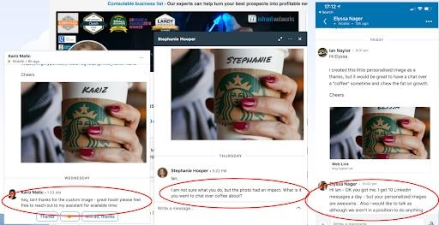

With messages tailored to each individual prospect, you’ll stand out in their inbox for sure.

Lucky for you, **SalesRobot has direct integration with Hyperise for automated hyper-personalization at scale**, ensuring no effort is wasted.

⭐**AI-Driven Campaign Building:**

Imagine a LinkedIn messaging campaign built from scratch by an AI tool.

**SalesRobot has made it a reality!**

From finding the right prospect segment to target to drafting messages and configuring follow-ups, **SalesRobot's SalesGPT can do it all in only 5 minutes.**



You need not be tech-savvy—**just talk to our AI tool in simple English**, and SalesGPT will complete your tasks immediately!

⭐**List Enrichment with Emails:**

While LinkedIn outreach is essential, **SalesRobot also excels in cold email campaigns.**

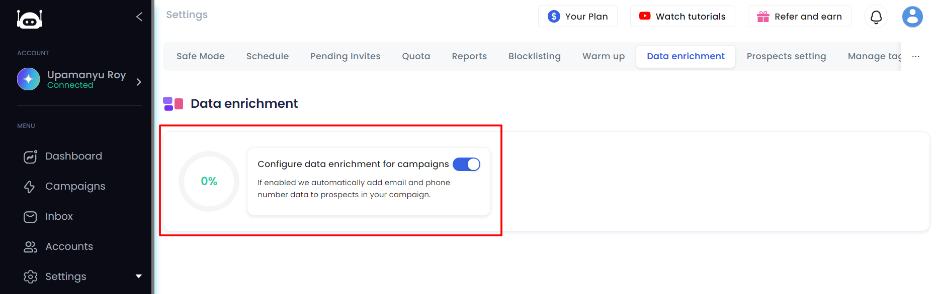

It offers **data enrichment features** for email addresses and phone numbers, ensuring comprehensive outreach.

⭐**Reports and Analytics:**

**Data is very important for planning long-term sales**. Without it, your campaign is like trying to find your way through a maze blindfolded.

**SalesRobot offers detailed analytics** on follow-up messages, connected prospects, group messages, and more.

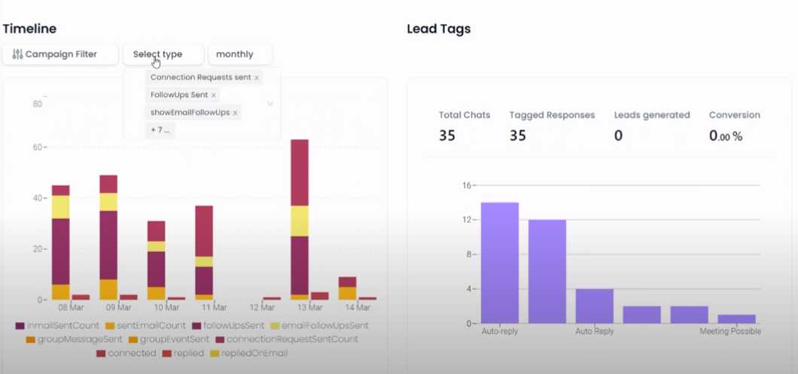

That's what keeps SalesRobot ahead of all LinkedIn automation tools.

But does that mean our prices are sky-high? Jump on to the next section and find out!

#### SalesRobot Pricing:

**SalesRobot offers a** [**simple pricing structure**](http://salesrobot.co/pricing) **and a** [**14-day free trial**](http://app.salesrobot.co/register), making it easy to see if it's the right tool for you.

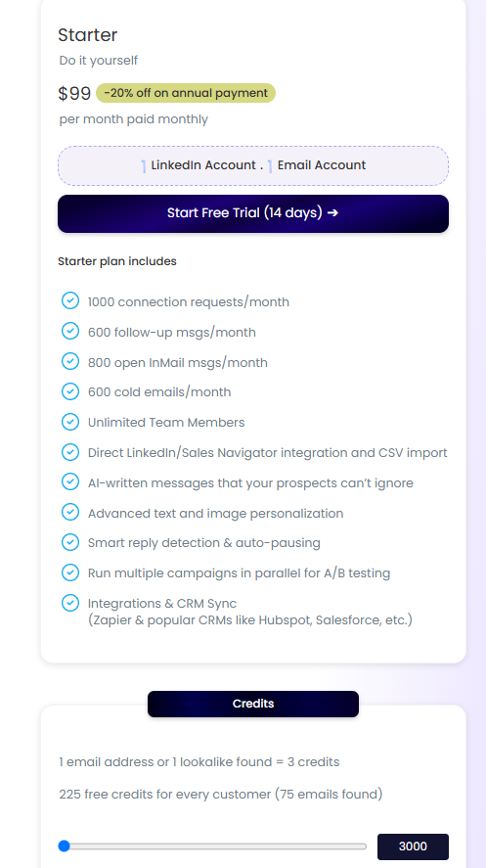

**Starter - $99/month -** Choose our DIY plan to connect with over 600 prospects and send tons of messages every month. It’s perfect if you like to do things yourself!

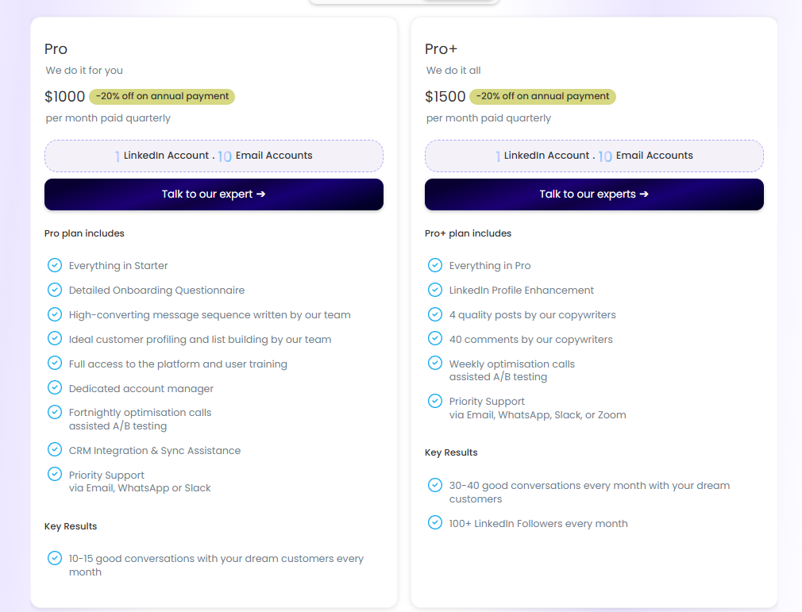

**Pro - $1000/month -** Get all the Starter benefits plus **personalized help and top-priority service**. We’ll even help you land your dream deal!

**Pro+ - $1500/month -** Enjoy all the Pro benefits and even more premium services. **Let us handle everything for you!**

You can also add extra services to the Pro and Pro+ plans from our **Optional Add-On pack**.

Get a **20% discount** if you subscribe annually!

Give SalesRobot a try and see how amazing it is!

Did we just solve all the problems you were worried about? We think so!

So why wait? Give us a try! **Plus, our 24/7 customer support is always here to help you. 😊**

Why not try SalesRobot's [**14-day free test drive**](http://app.salesrobot.co/register) and see how it can help your business?

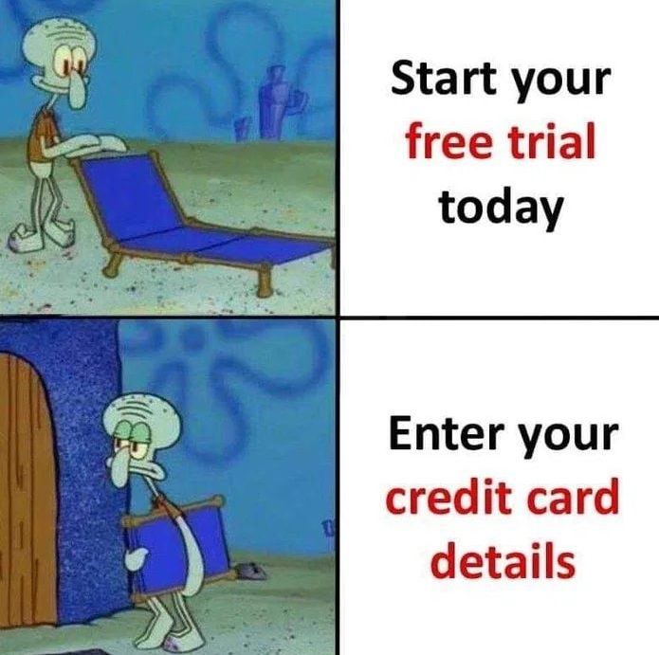

Are you worried about this situation? With SalesRobot, you need not be!

**You don't need to give your credit card details or phone number to enjoy the free trial!**

#### SalesRobot Cons

Obviously, not every tool is perfect. So we’ll talk about what’s wrong with SalesRobot to show we’re not biased.

There’s **no in-built dialer** in SalesRobot so **cold calling campaigns are not down our alley.**

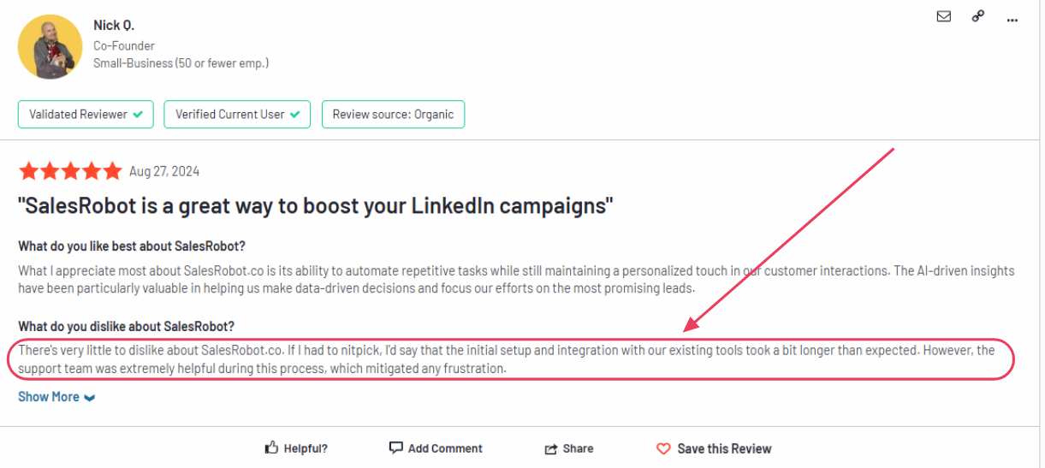

Some users have faced occasional hiccups during the set-up process. But that’s why we have such fantastic customer support 24/7

Besides that, we also have our own [YouTube channel](https://www.youtube.com/channel/UCVWhK0NkBdHvsAB593LW5Qg) at your service, where you can find all kinds of helpful tutorials.

And… well I can’t really remember any more right now. But I’d love it if you [gave it a try](https://app.salesrobot.co/register) and gave us some feedback on what you think!

### Reply.io: Elevate Your B2B Sales with Seamless Cold Calling Integration

[Reply.io](https://reply.io/) is a **sales automation platform** that supports **both inbound and outbound methods** to streamline your sales process.

It can **send emails, make calls, and even help with tasks like leaving voicemails.**

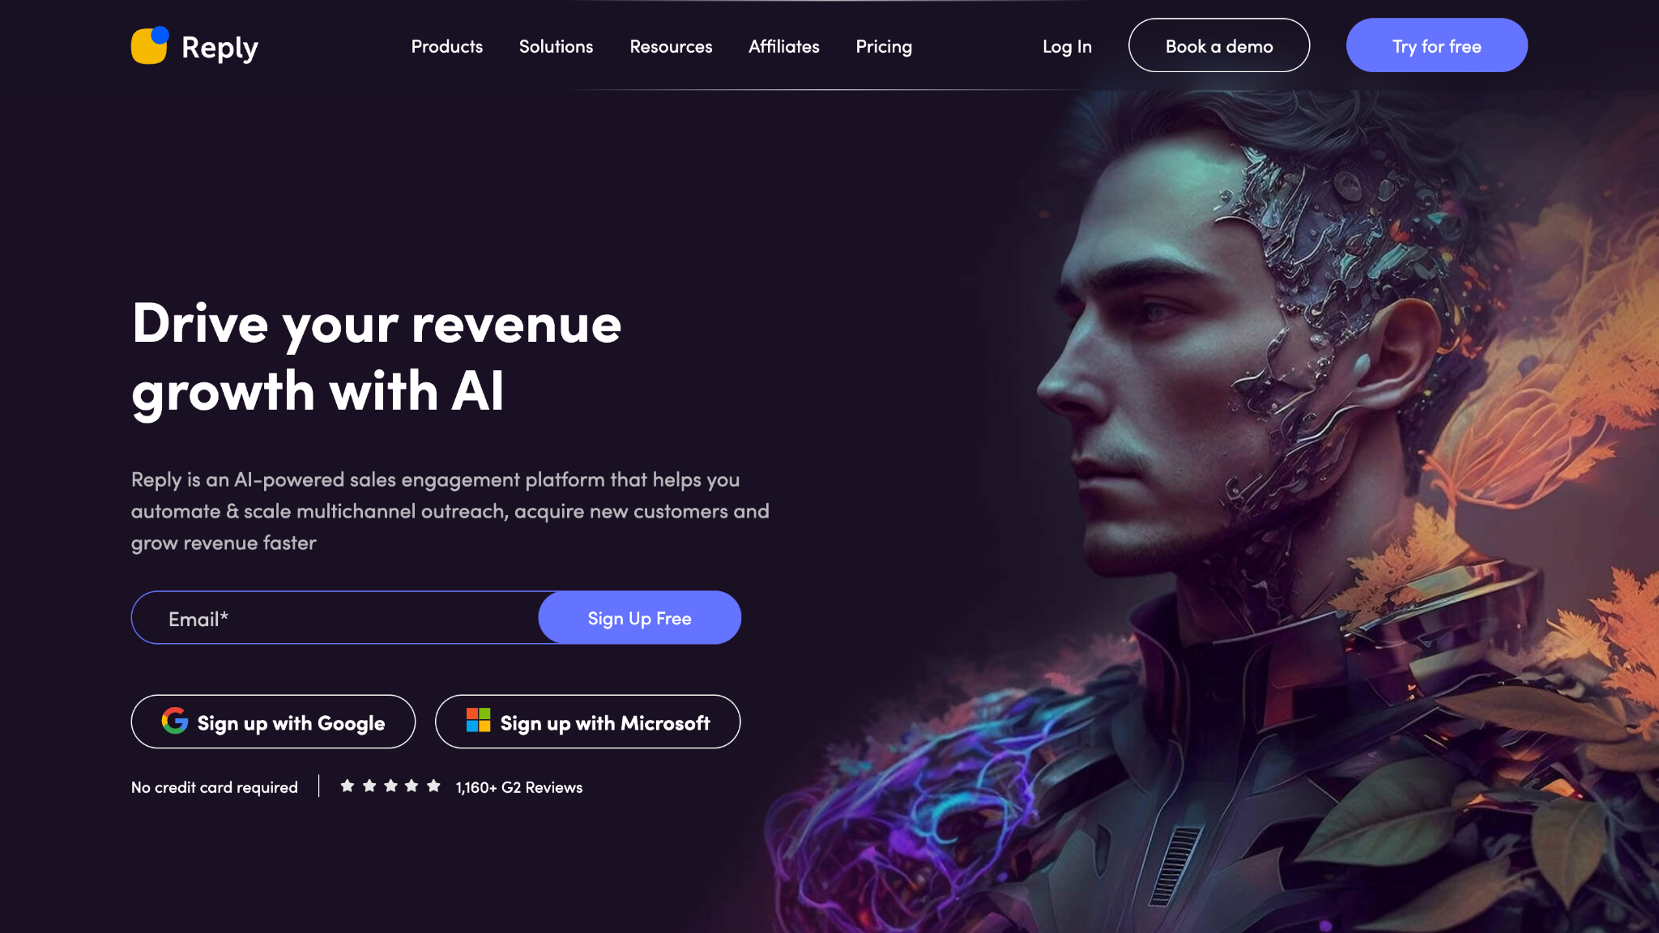

Source: Reply.io

Here is more on how Reply.io can help you -

**Reply.io is great for experimenting with different ways to find new customers**. Its multichannel features allow you to contact people through email, SMS, WhatsApp, and LinkedIn all in one place.



Source: Reply.io

Using Reply.io’s **Chrome Extension**, you can easily get contact info from LinkedIn.

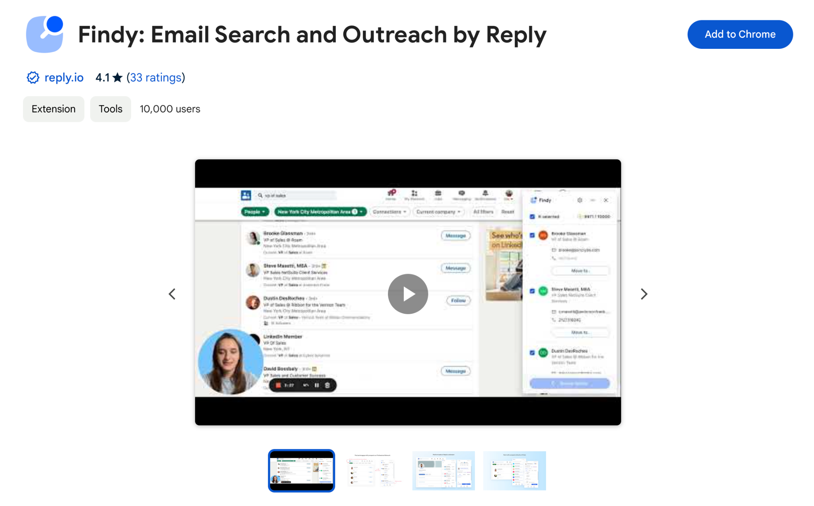

Source: Chrome Webstore

**Reply.io has an inbuilt dialer and supports cloud calling**, which can be used to make phone calls, but user reviews indicate that it does not perform very well.

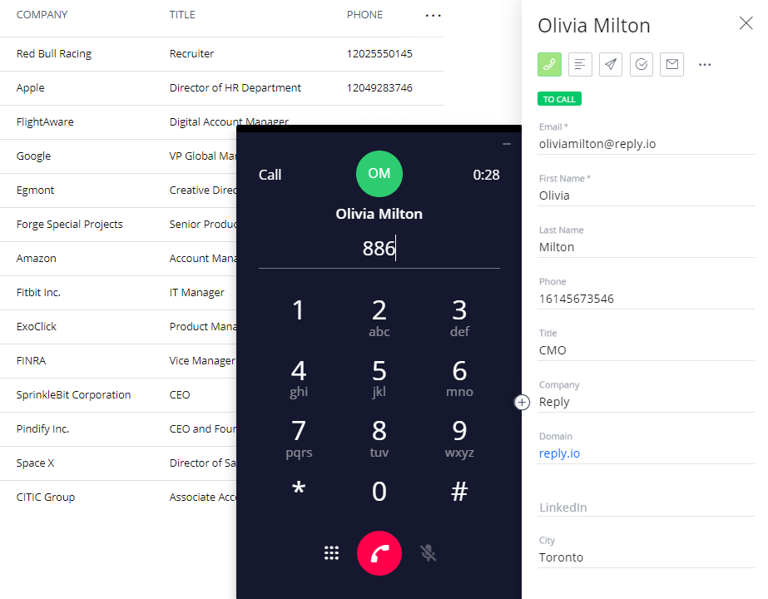

Source: Reply.io

Reply.io **analyzes your email's content using artificial intelligence** and suggests enhancements to increase your chances of getting a response.

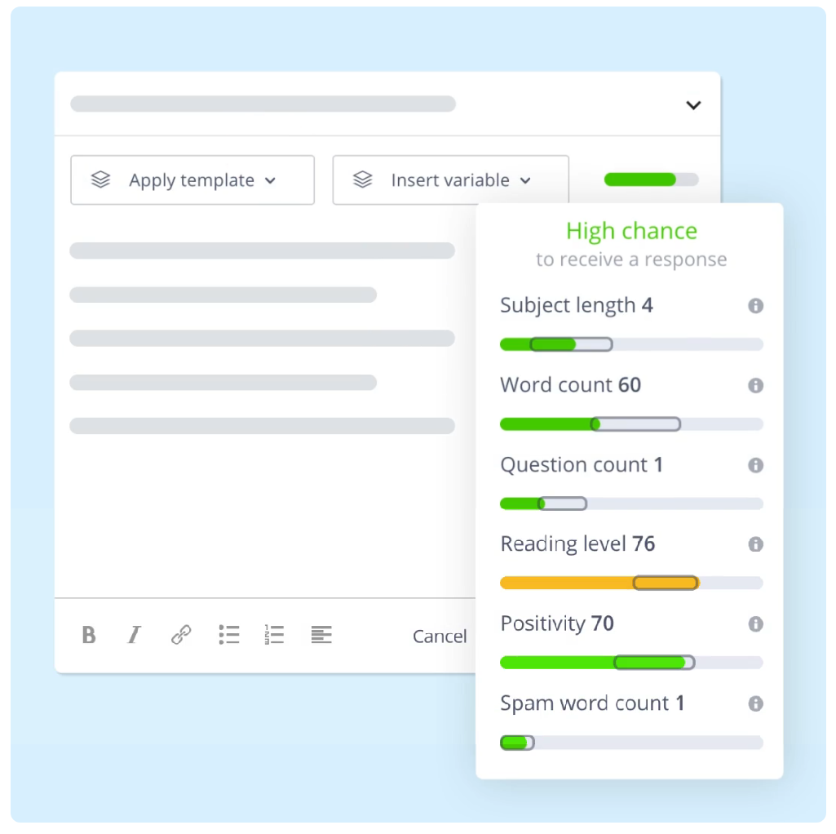

Source: Reply.io

**Even though it works with many CRMs, its integration is limited,** which can be a downside for teams using specific tools.

#### Reply.io Cons

* **Limited integrations with other tools**

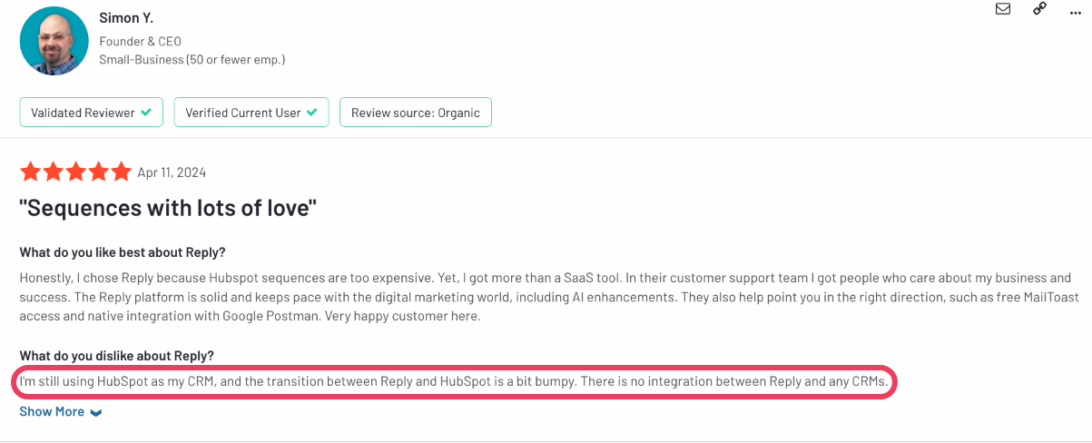

Source: G2

* **Lack of safety in bypassing LinkedIn limits** and **buggy Chrome extension.**

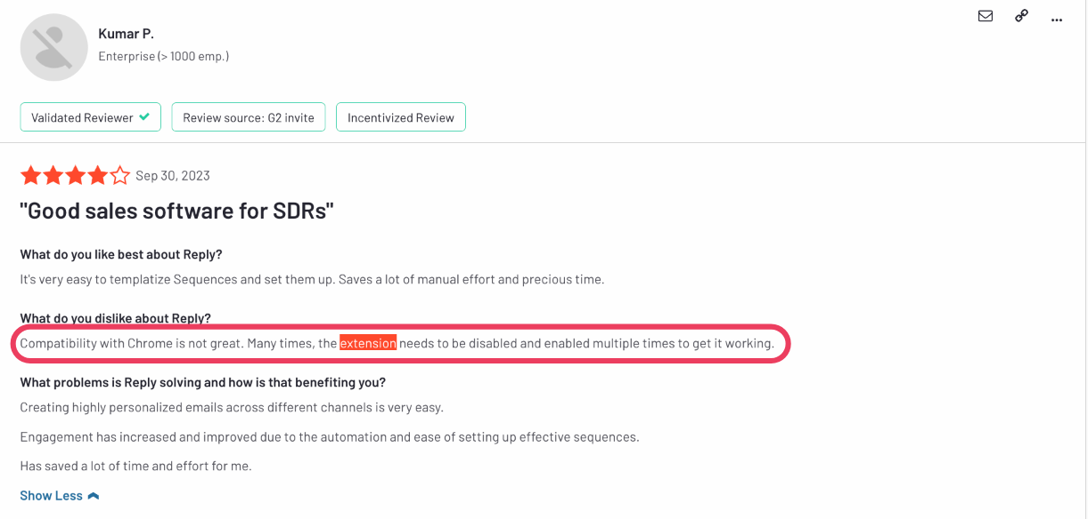

Source: G2

* **Unsatisfactory customer support**

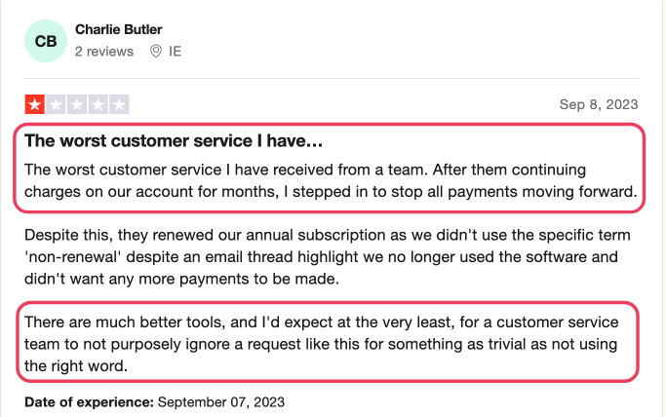

Source: Trustpilot

* **Unfriendly user interface and buggy tool**

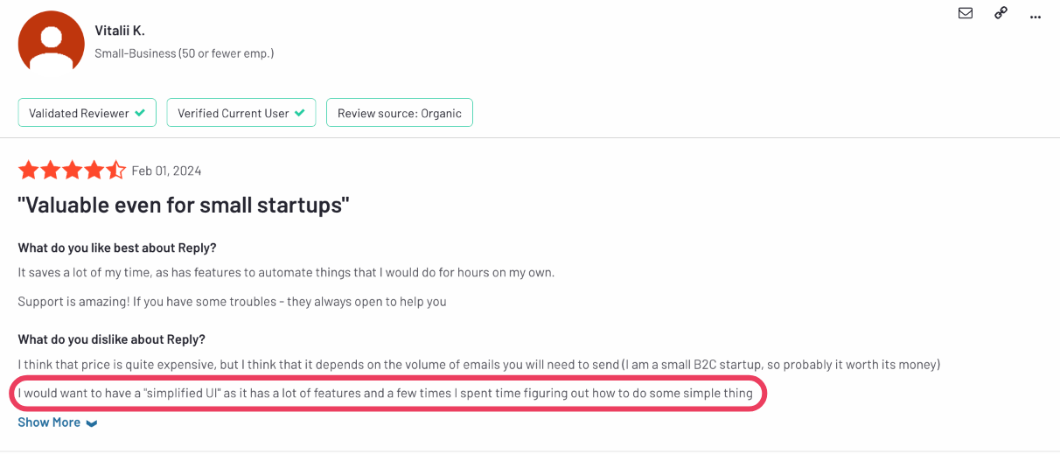

Source: G2

#### Reply.io Pricing

Reply.io offers a free trial for 14 days. They offer three pricing plans:

**Sales Engagement:**

There are three levels:

* **Email Outbound for $59** per month - You can reach out to 1,000 people each month. You get unlimited email warmup, storage, and users. Plus, you get 1,000 data search credits and a special inbox.
* **Multichannel for $99** per user, per month - Five mailboxes per user, and endless email warmup, storage, and emails. This plan also comes with a special inbox and anti-spam feature.
* **Agency for $210** per month - Unlimited mailboxes, email warmup, and storage, Plus, you get 10,000 data search credits and a support team.

**AI SDR**

This plan is for you if you want 1,000 active contacts and AI-created customer profiles. It offers high-accuracy emails and autopilot modes and is priced at **$350 per month.**

**AI Chat**

Exclusively to automate your inbound salesflow, this plan price starts from **$49.50 per month.** With unlimited chatbots and messages, you get 50 captured contacts per month, in-chat meeting booking, and lots of data for training.

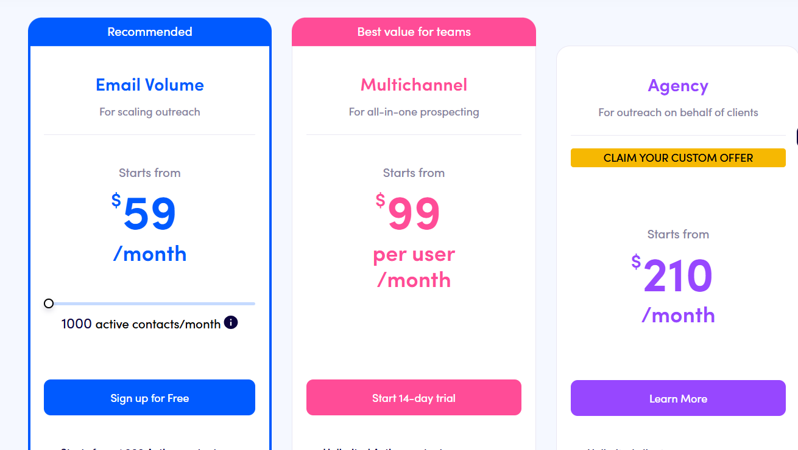

Still unsure if this is the right tool for you? Read our [in-depth review of Reply.io.](https://www.salesrobot.co/blogs/reply-io-review)

## **Conclusion**

Let's have a quick recap of Outreach.io and its alternatives.

* **Outreach.io** is great for managing sales pipelines and integrating with other tools. It’s like having an all-in-one platform for sales teams, from sales engagement to forecasting to call recording, but it can be pricey.
* **Reply.io** is perfect for automating emails and multichannel outreach. It’s like a Swiss Army knife for sale, but sometimes, the features don’t work perfectly.
* [**SalesRobot**](https://www.salesrobot.co/) stands out with its all-in-one sales automation, AI-powered personalization, and LinkedIn safety features.

It boosts response rates and makes your sales process super smooth.

And you don’t have to just take my word for it, [just check out our reviews on G2!](https://www.g2.com/products/salesrobot/reviews)

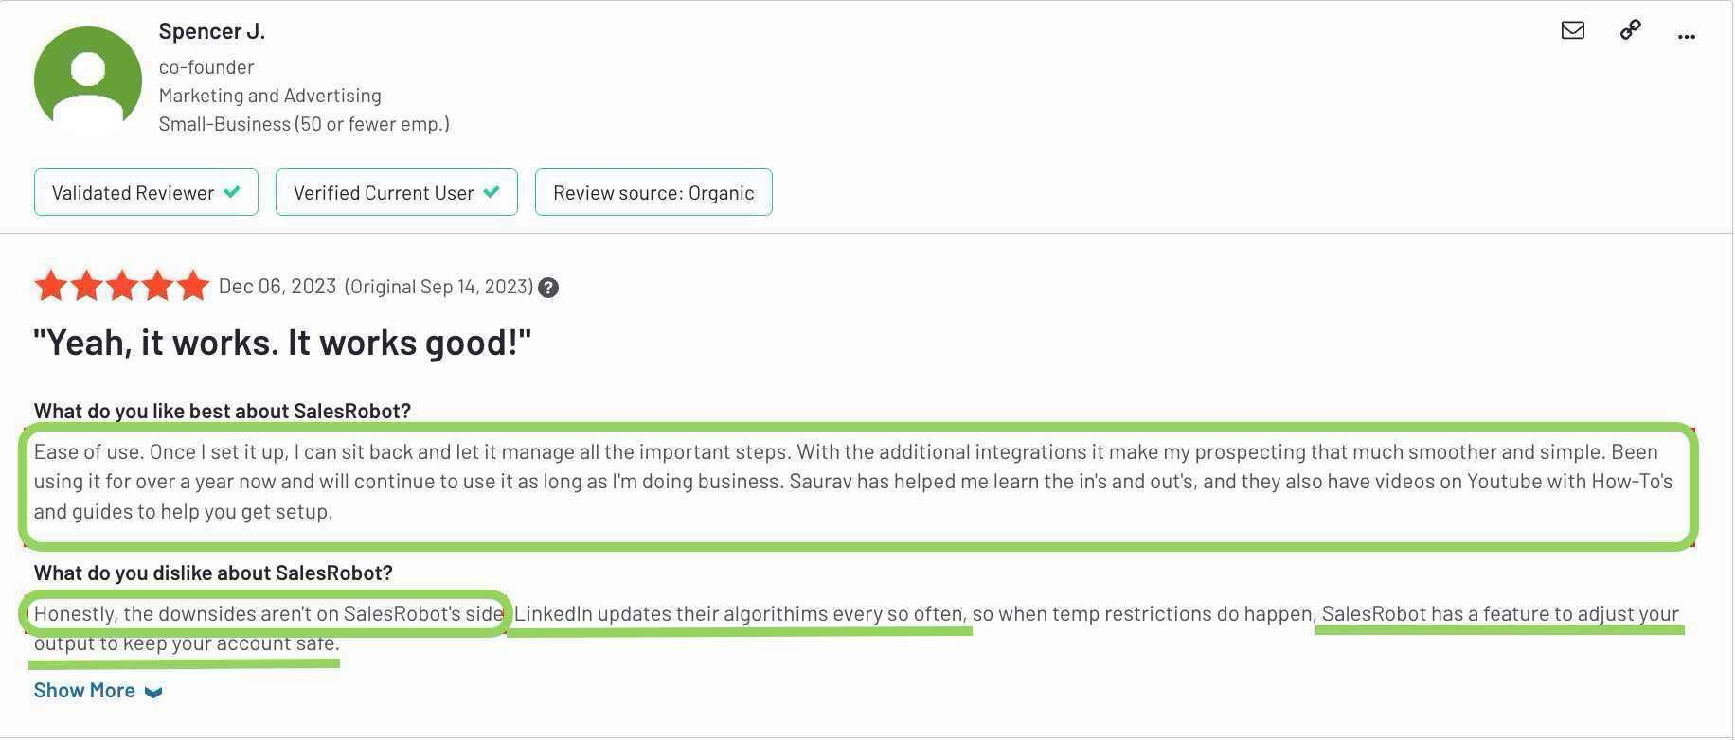

Source: G2

And if that’s not enough, I recommend you test it out for yourself and see if it works,

Sign up for the[**14-day trial version**](https://app.salesrobot.co/register)! (No credit card or phone number needed!).

Let’s take your sales game to the next level with top-notch automation.

We hope you enjoyed this in-depth Outeach review!

Thanks for reading!